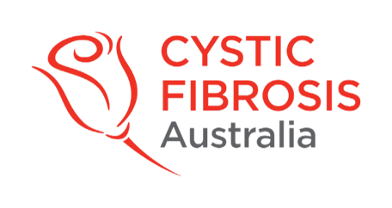

7 February 2024

Dear Cystic Fibrosis Community,

The organizing committee of the 2024 Australasian Cystic Fibrosis Conference is thrilled to invite abstract submissions from delegates who wish to contribute to the conference's wealth of knowledge and discussion. This is an excellent opportunity for authors to showcase their research, share their vision and experiences, and widen their impact. We are delighted to announce that, for the first time, abstracts selected for presentation at the conference will be published in the Journal of Respirology, thus allowing authors to gain recognition for their breakthroughs and contribute to improving outcomes in cystic fibrosis.

Key Details:
- Submission Period: Open from Monday, January 29th to Tuesday, March 5th, 2024.
- Publication Opportunity: All accepted abstracts will be featured in the prestigious Journal of Respirology
- Theme: “Connect & Conquer: Advancing Cystic Fibrosis Care”

Why Submit Your Abstract?
- Global Visibility: Showcase your work to an international audience of professionals, researchers, and advocates.
- Publication: Enhance your professional profile by having your abstract published in the esteemed Journal of Respirology.
- Networking: Connect with experts and peers in the cystic fibrosis community, fostering collaboration and knowledge exchange.

How to Submit: Visit our conference website for detailed guidelines and the online submission portal.
Abstract Submission Portal

Don't miss out on this extraordinary opportunity to contribute to the advancement of cystic fibrosis knowledge. Submit your abstract now and be part of shaping the future of care and research in our community.

Learn more and submit your abstract via the conference website:
Conference Website

We look forward to receiving your valuable contributions.

Best regards,

The Australasian Cystic Fibrosis Conference Committee 2024

