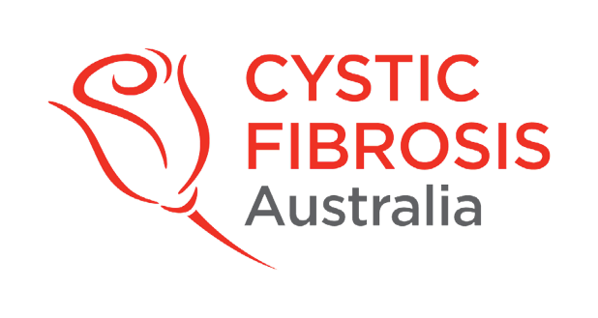

26 July 2023

INNOVATION GRANT 2021 – Sponsored by CFSA

Project titled: Sphingosine-1 phosphate and zinc - novel mediators of vascular dysfunction in children with CF.”
Principle Investigator: Dr Andrew Tai

Contributory factors to CF mortality may include complications such as endothelial dysfunction (ie abnormal thin lining of blood vessels) that develop in adulthood. We hypothesised that increased leukocyte (ie a type of cell in the body’s immune system) expression of vasoconstriction and pro-fibrotic mediators (ie contributors to scarring of lung tissue) may promote endothelial dysfunction in adult CF patients and be detectable in children with CF. Although no significant changes were noted in the paediatric cohort, leukocytes from adult CF patients expressed significantly higher levels of fibrotic markers that inversely correlated with CF severity. We conclude that pro-fibrotic and vasoconstriction molecules expressed by leukocytes may contribute to CF severity, highlighting potential therapeutic strategies to improve clinical outcomes in patients with CF.

This research has been submitted to a journal entitled “Clinical and Experimental Medicine” and is currently being reviewed for publication.

